**A Quick Look at a Retail Sales Dataset**

**Introduction: Unveiling Retail Trends with Kaggle Data**

While understanding customer buying habits and product performance is crucial for success in the retail industry, vast amounts of data can be overwhelming. This project, undertaken during my internship at HNG Tech, <https://hng.tech/internship>, <https://hng.tech/hire>, a leading tech company fostering innovation, tackles this challenge. We explored a publicly available retail sales dataset downloaded from Kaggle. Our goal? To gain a quick grasp of the data and identify initial trends through data exploration and visualization techniques within Excel and PowerBI. By delving into key sales metrics and product categories, this "first glance" analysis will provide a springboard for further investigation and data-driven insights to optimize retail strategies.

**Observations**: **A Diverse Customer Base**

We examined sales data from 2003 to 2005, finding a total of 2,823 orders placed, though only 92.7% shipped successfully, indicating a need for improvement in order fulfillment. These orders spanned a limited range of just 7 products, with Classic Cars reigning supreme at $3,919,616 in sales and peaking in 2004. Vintage Cars followed at $1,903,151 (peaking in 2004), and Motorcycles rounded out the top three at $1,166,388 (also peaking in 2004). While 2004 appears as the most profitable year, data for 2005 only covers the first five months, potentially skewing the results.

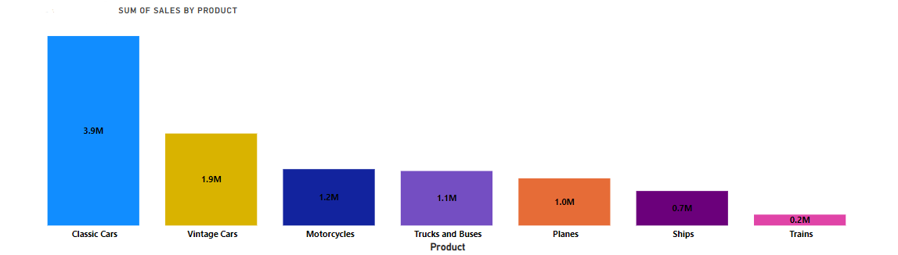

Sum of Sales by Product

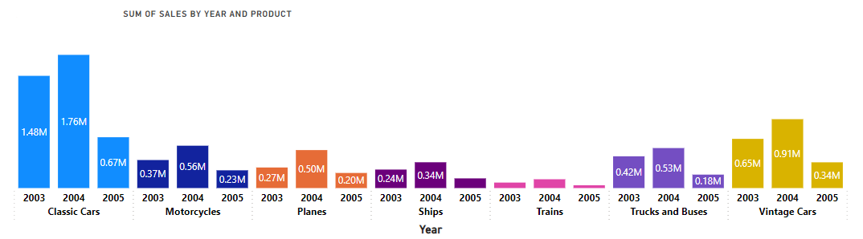

Sum of Sales by Year and Product

A first glance at the retail sales data paints a promising picture. Total sales hit $10 million, with customers typically placing orders for 35 items each. This diverse customer base spanned an impressive 19 countries, with the US leading the pack at $3.6 million. Strong international demand is further evidenced by Spain and France coming in second and third, with sales of $1.2 million and $1.1 million respectively.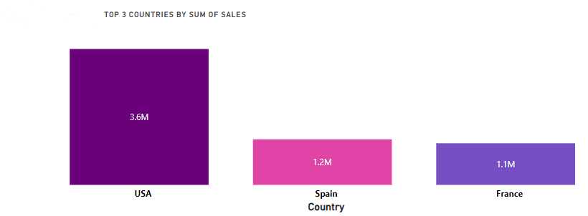

Order sizes skewed towards smaller quantities. The majority of orders, representing nearly half (49.03% or 1,384 orders), fell into the "Medium" category. "Small" orders followed closely behind at 45.41% (1,282 orders), indicating a customer preference for smaller purchases. Large orders comprised only 5.56% (157 orders) of the total.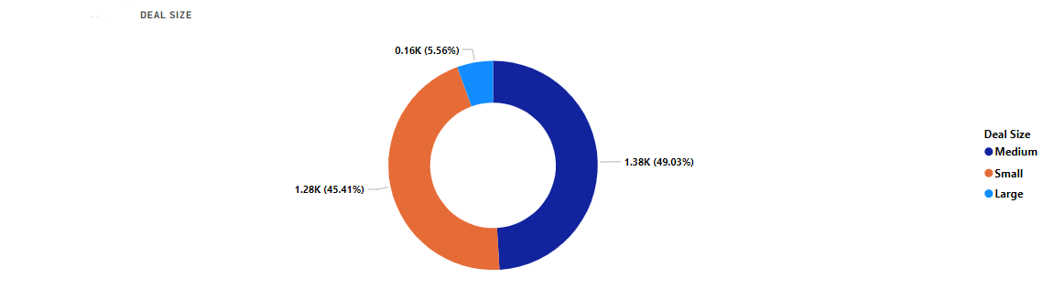

**Conclusion**: **A Springboard for Data-Driven Retail Success**

This initial analysis of the retail sales data, undertaken during my internship at HNG Tech [Link to HNG Tech Website], reveals valuable insights to inform future strategies. The overall sales picture is promising, with a strong total of $10 million and a diverse customer base spanning a remarkable 19 countries. The identification of top performers like the US, Spain, and France highlights the effectiveness of existing marketing approaches in these regions.

However, this "first glance" also unveils opportunities for improvement. The order size distribution, with a majority of orders falling under "Medium" and "Small" categories, suggests potential for product bundling or upselling strategies to cater to customers seeking larger purchases. Additionally, the less-than-ideal shipment success rate of 92.7% indicates a need to investigate and potentially streamline order fulfillment processes.

This project serves as a springboard for further exploration. By delving deeper into the data, we can unlock a wealth of knowledge about customer demographics (if available). Analyzing these demographics alongside order size distribution could reveal interesting correlations, informing targeted marketing strategies for specific customer segments. Additionally, investigating individual product performance within categories and profitability across different regions can provide even richer insights for optimizing product offerings and resource allocation.

Armed with this data-driven understanding, retailers can refine marketing strategies, expand product offerings based on customer needs and sales trends, and streamline order fulfillment to ultimately maximize customer satisfaction and profitability.

Remember, in the vast landscape of retail data, a "first glance" is a powerful first step. This exploration demonstrates the immense value of data analysis in the retail industry. So, the next time you're faced with a mountain of data, remember – the insights you uncover might just pave the way for data-driven success.